**Assignment 25.1**

**Loading Olympic Data:**

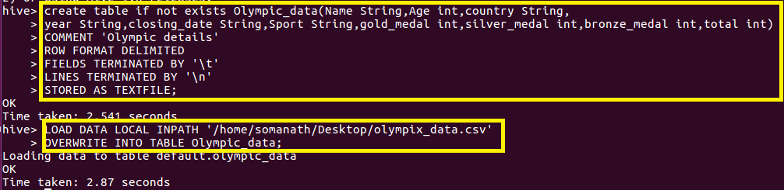

1. **Write a Hive program to find the number of medals won by each country in swimming. Since we want the number of medals won by each country in swimming group by country and filtered by swimming.**

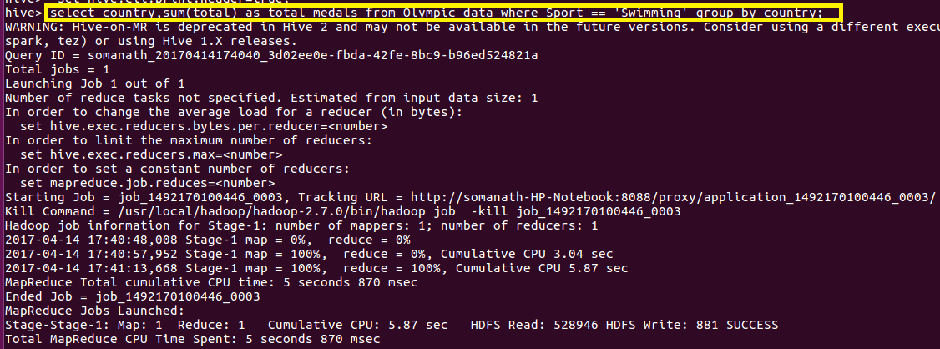

**Output:**

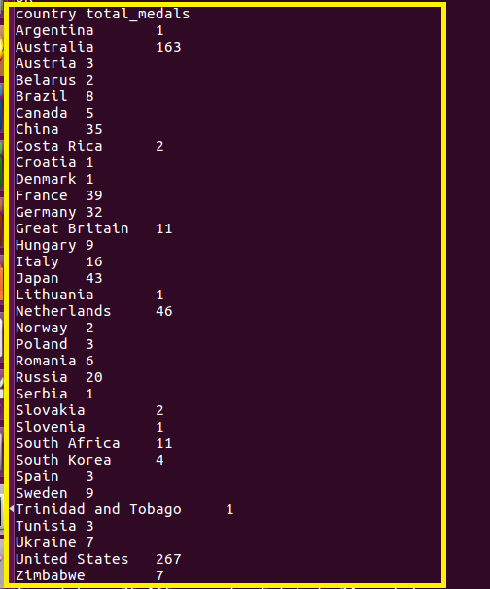

1. **Write a Hive program to find the number of medals that India won year wise. Since we want medal won by India year wise, group by year and filter by country equal to India.**

